Business Requirement Document

Annual Vehicle Efficiency Report
MyEicher Portal - EV Fleet Reporting
Requirement summary
Add a standard Annual Vehicle Efficiency Report under Fleet Monitoring > Reports for MyEicher Portal. The report auto-loads the latest 12 completed months, shows annual EV efficiency in kWh/km, month-wise efficiency trend, vehicle-wise annual efficiency, backend-derived Deviation, Status, Top Indicator, and Excel/PDF exports.

Field | Details
Product area | MyEicher - EV fleet reporting
Platform | Web Portal only. Android/iOS to be covered separately.
Module placement | Our Services > Fleet Monitoring > Reports > Annual Vehicle Efficiency Report
Primary metric | Vehicle Efficiency = Total Power Consumption / Distance Travelled
Primary unit | kWh/km. Lower value indicates better energy efficiency.
Primary data source | Primary Daily Aggregate Table
Design reference | Figma / VD link included in Section 6
Document status | Final Version

Document Sections
- Version Control; Business Objective; Problem Statement; Scope; User Journey; Figma/VD Links
- Functional and Non-Functional Requirements; Data Requirements including Usage Count
- User Stories; Acceptance Criteria; Dependencies; Assumptions

1. Version Control

Version | Date | Owner | Change Summary | Status
0.2 | 22-Jun-2026 | Product Manager - EV | BRD updated for MyEicher Portal Annual Vehicle Efficiency Report with final UI behaviour, data source, export, and backend logic. | Final Version

2. Business Objective

Create a customer-facing Annual Vehicle Efficiency Report for EV fleets in MyEicher Portal. The report should help customers and internal teams review annual energy efficiency in kWh/km, understand month-wise variation, identify underperforming vehicles, and export the annual efficiency report for business review.
Item | Definition
Primary users | Fleet managers, depot/operations teams, customer account teams, product/service teams
Business value | Provides a clear annual EV efficiency view and supports customer discussions where monthly summer consumption may be higher due to AC load.
Core principle | Keep the page simple and focused on annual vehicle efficiency. Do not convert it into a broad fleet health, green savings, charging, or uptime report.
Portal scope | This BRD applies to MyEicher Web Portal only. Android/iOS shall be addressed separately.

3. Problem Statement

- Existing reports provide selected-duration and monthly efficiency data, but there is no dedicated annual report that auto-loads the latest 12 completed months.
- Customers need an annual efficiency view because individual summer months can show higher kWh/km due to AC consumption, while full-year performance may still be acceptable.
- Mixed EV fleets such as Pro X and buses cannot be compared using one common fleet average; backend logic must compare vehicles by model or segment.
- Customers need simple action pointers for high kWh/km vehicles without exposing complex technical calculations on the UI.

4. Scope

In Scope | Out of Scope
New Annual Vehicle Efficiency Report tab under Fleet Monitoring > Reports. | _
Auto annual period using latest 12 completed months. | Customer-facing date/duration filter.
Four KPI cards, month-wise bar chart, vehicle-wise annual table. | Manual custom report builder flow for this use case.
Page-level vehicle search that updates cards, chart, table, and export. | Charging event analysis, green savings, diesel saved, CO2 saved.
Status and Top Indicator filters for the vehicle table. | Idling, stoppage, low energy recovery, or power gained indicators in MVP.
Backend-derived Deviation, Status, and Top Indicator. | Raw CAN packet calculation on UI load.
Excel and PDF export following existing MyEicher export style. | Customer-visible model benchmark/comparison basis column.

5. User Journey

Step | User Action | Expected System Behaviour
1 | Open Our Services > Fleet Monitoring > Reports > Annual Vehicle Efficiency Report. | Report opens in default All Vehicles mode with latest 12 completed months already applied.
2 | Review the four summary KPI cards. | Cards show fleet-level Vehicles Operated, Total Distance Travelled, Total Power Consumption, and Fleet Vehicle Efficiency.
3 | Review month-wise bar chart. | Chart shows month-wise fleet kWh/km. Highest month is red, lowest month is green, others are blue.
4 | Review vehicle-wise annual table. | Table shows vehicle annual distance, TPC, kWh/km, Deviation, Status, and Top Indicator.
5 | Search/select a vehicle number in the top search field. | Selected vehicle filter is applied across cards, chart, table, and export.
6 | Clear the searched vehicle. | Report resets to default All Vehicles mode.
7 | Export report. | Excel/PDF export respects current context: All Vehicles or selected vehicle.

6. Figma / VD Links and UI References

Figma / VD Link: https://www.figma.com/design/Ujmr1AvnKw5rzjuy6uviq2/Annual-Vehicle-Efficiency-Report?node-id=0-1&p=f&t=FQUVpJbCzMafapW6-0
Reference | Details
Navigation placement | Annual Vehicle Efficiency Report will be available under Our Services > Fleet Monitoring > Reports.
Default view | All Vehicles mode with four KPI cards, month-wise fleet efficiency chart, and vehicle-wise annual table.
Vehicle search view | Selected vehicle mode where the same vehicle search is applied across the page.
Export reference | Excel/PDF exports should follow existing MyEicher report export layout.

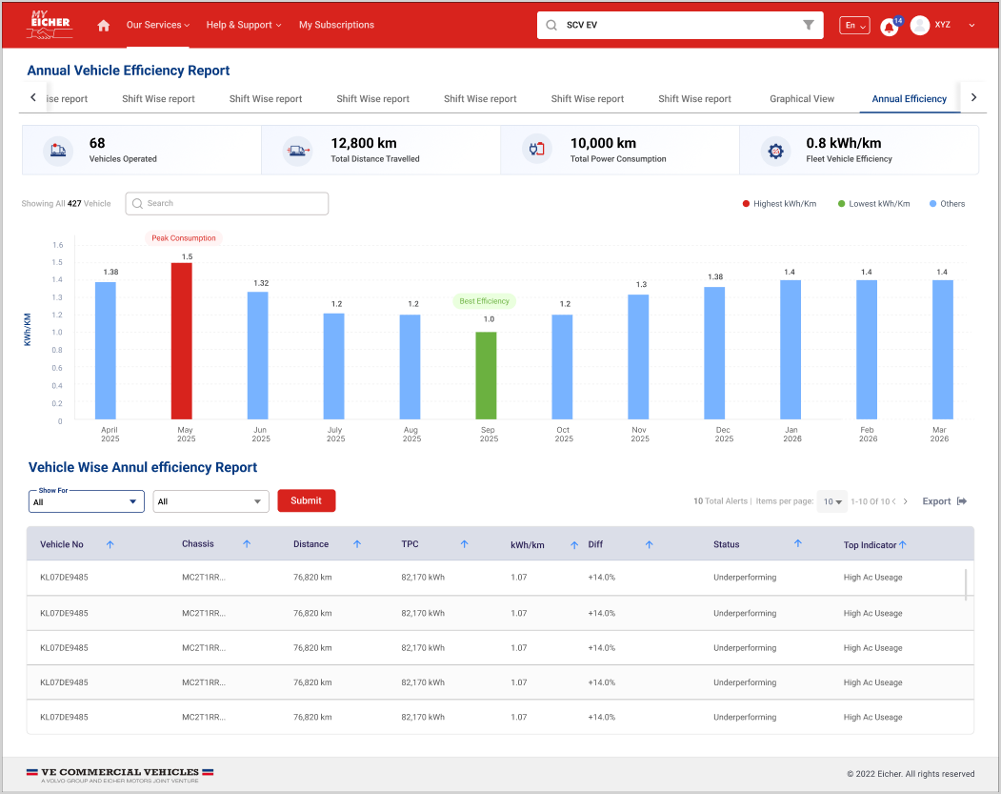
Figure 1: Planned default All Vehicles view.
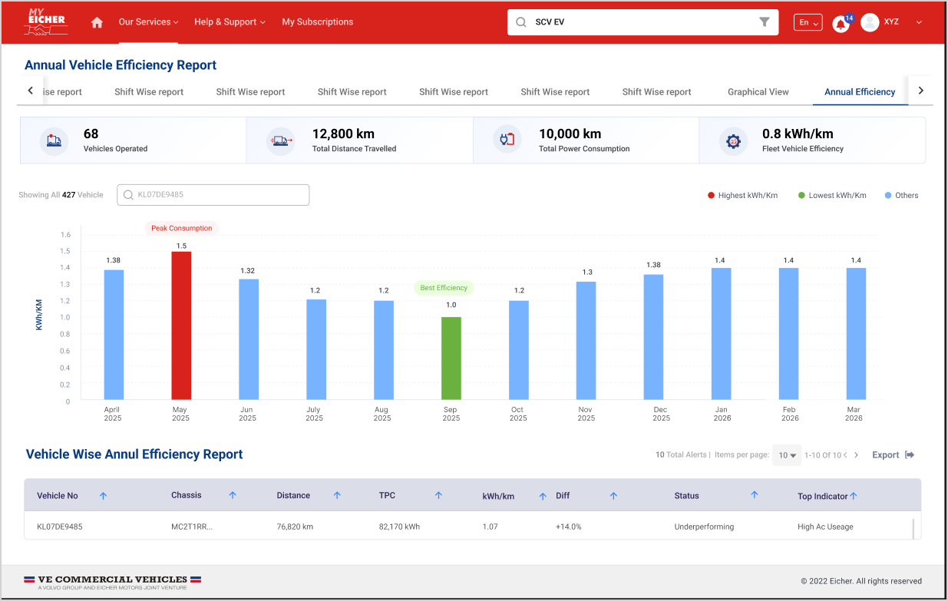
Figure 2: Planned selected vehicle view after vehicle number search.
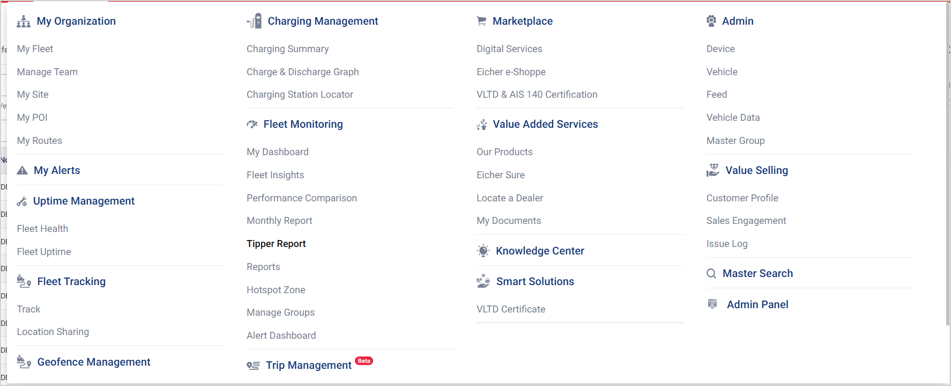
Figure 3: Existing MyEicher navigation reference for Fleet Monitoring > Reports.

7. Functional Requirements

7.1 Page Entry and Annual Period
Req ID | Requirement | Details
FR-01 | Add new report tab | Add Annual Vehicle Efficiency Report under Fleet Monitoring > Reports.
FR-02 | Auto annual period | Report shall auto-load latest 12 completed months. Example: opened in July 2026, period is July 2025 to June 2026.
FR-03 | No duration filter | No date picker, duration selector, or custom date range shall be shown. Annual period shall be shown as a read-only label.
FR-04 | Existing access control | Existing MyEicher account and vehicle visibility rules shall apply.

7.2 Summary KPI Cards
Card | Metric / Logic | Unit
Vehicles Operated | Count of distinct vehicles with valid annual operation during the annual period. | Count
Total Distance Travelled | Fleet sum of distance travelled by operated vehicles during annual period. | km
Total Power Consumption | Fleet sum of Total Power Consumption during annual period. | kWh
Fleet Vehicle Efficiency | Total Power Consumption / Total Distance Travelled. Lower value is better. | kWh/km

Card decision
Peak Consumption Month and Best Efficiency Month shall not be separate KPI cards. They shall be shown only in the chart using red and green bars.

7.3 Month-wise Efficiency Chart
Mode | Chart Behaviour
Default All Vehicles mode | Chart title: Month-wise Fleet Efficiency Trend. Shows monthly fleet kWh/km for the 12 months in the annual period.
Selected vehicle mode | Chart title: Month-wise Vehicle Efficiency Trend - <Vehicle No.>. Shows monthly kWh/km for the selected vehicle only.
Visual treatment | Highest kWh/km month in red, lowest kWh/km month in green, all other months in blue.
Tooltip | Month, Distance Travelled, Total Power Consumption, and kWh/km.

7.4 Global Vehicle Search Behaviour
Important UI behaviour
The vehicle number search is a page-level vehicle context filter, not only a table search.

Section | Default Mode | After Vehicle Search
KPI cards | Fleet annual values | Selected vehicle annual values
Bar chart | Fleet month-wise kWh/km | Selected vehicle month-wise kWh/km
Vehicle table | All vehicles | Selected vehicle only
Export | All-vehicle annual report | Selected vehicle annual report
Clear search | Not applicable | Clearing search resets full page to All Vehicles mode

7.5 Vehicle-wise Annual Efficiency Table
Column | Requirement
Vehicle No. | Show vehicle registration number. Partial-Year tag may be shown beside vehicle number if applicable.
Chassis No. | Show for identification and export consistency.
Model | Show to support mixed fleet context such as Pro X and buses.
Distance | Annual distance travelled.
TPC | Annual Total Power Consumption.
kWh/km | Annual vehicle efficiency.
Deviation | Backend-calculated deviation against same model/segment benchmark. Positive deviation is worse.
Status | Good, Average, Underperforming, or Review Required.
Top Indicator | High AC Load, Driving Behaviour, Data Review Required, or No Major Indicator.

7.6 Table Filters
Filter | Values | Behaviour
Status Filter | All, Good, Average, Underperforming, Review Required | Applies only to vehicle-wise annual table.
Top Indicator Filter | All, High AC Load, Driving Behaviour, Data Review Required, No Major Indicator | Applies only to vehicle-wise annual table.

7.7 Deviation, Status, and Top Indicator
Item | Logic
Deviation | Calculated in backend using comparable same-model or same-segment benchmark. Customer sees only deviation percentage, not comparison basis.
Good | Deviation < -5%.
Average | Deviation between -5% and +10%.
Underperforming | Deviation > +10%.
Review Required | Data is abnormal, insufficient, or requires validation.
High AC Load | AC Power Consumption in Running is materially higher than same-model/segment values.
Driving Behaviour | HA/HB/Overspeeding rate per 100 km is materially higher than same-model/segment values.
Data Review Required | Customer-facing label for abnormal efficiency/data; do not show Data Issue.
No Major Indicator | No supported indicator crosses threshold.

Mixed fleet rule
For customers with mixed EV products such as Pro X and buses, the backend shall calculate deviation model-wise or segment-wise. The UI shall not compare all vehicle types against one common average.

7.8 Export Behaviour
Export Type | Required Content
Excel | Report name, Output For, Annual Period, Vehicles Operated, Total Distance Travelled, Total Power Consumption, Fleet/Vehicle Efficiency, and vehicle-wise annual table. Export shall respect current context and table filters.
PDF | Report title, annual period, summary KPIs, month-wise chart, vehicle-wise annual efficiency table, and generated date/time. Export shall respect current context.

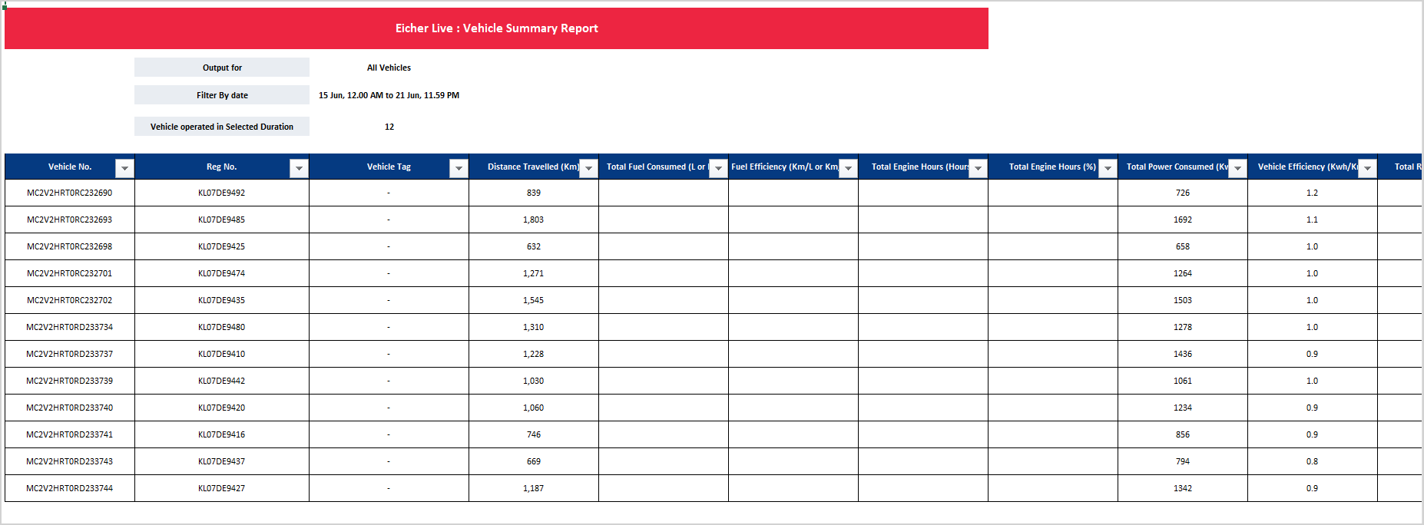
Figure 4: Existing MyEicher Excel/PDF export style reference.

7.9 Empty, Loading, and Error States
Scenario | Expected Behaviour
No operated vehicles | Show zero vehicles and message: No operated vehicles available for the annual period.
No searched vehicle match | Show message: No vehicle found for the entered vehicle number.
Distance = 0 or TPC = 0 | Show kWh/km as N/A and Status as Review Required where applicable.
kWh/km > 2.00 or < 0.20 | Show kWh/km as N/A, Status as Review Required, Top Indicator as Data Review Required.
Export failure | Show standard MyEicher export failure message and allow retry.

8. Non-Functional Requirements

Category | Requirement
Performance | Report shall use pre-aggregated daily/monthly data. UI must not trigger raw one-year CAN packet computation.
Scalability | Report shall support large fleets through backend roll-ups and paginated vehicle table.
Security and access | Existing MyEicher account, customer, and vehicle visibility rules shall apply.
Data consistency | Export values must match UI values for the same annual period, filters, and vehicle context.
Usability | No date/duration filter. Search, status filter, top indicator filter, and export should follow existing MyEicher patterns.
Auditability | Exports shall include report name, annual period, output context, and generated date/time.

9. Data Requirements - Including Usage Count

9.1 Primary Data Source
The Annual Vehicle Efficiency Report shall consume data from the Primary Daily Aggregate Table. The report shall not fetch raw CAN packets on screen load. The Custom Parameters screen only confirms availability of existing KPIs and shall not be used as the customer-facing source for this standard report.
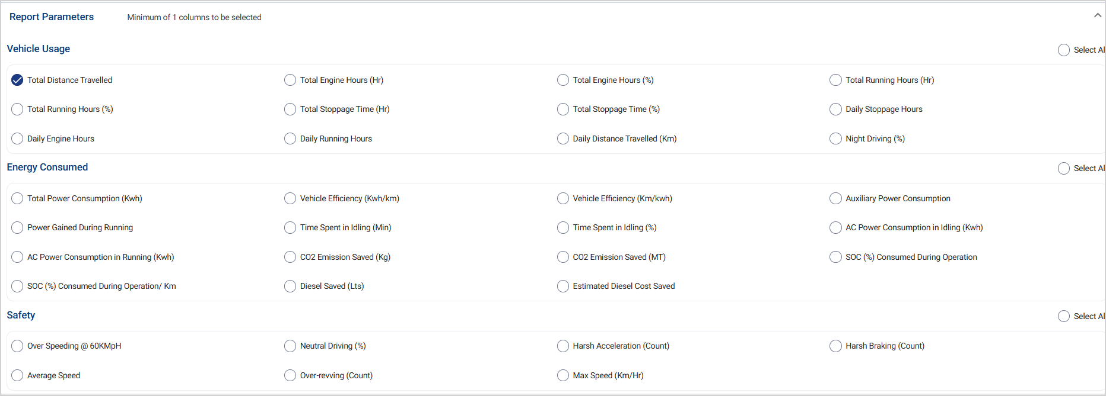
Figure 5: Existing Custom Parameters reference showing required KPI availability.

9.2 Required Data Fields
Field | Purpose
Vehicle No. / Reg No. | Table, search, export
Chassis No. | Table, search, export
Model / Segment | Same-model or same-segment backend comparison
Date | Monthly and annual roll-up
Distance Travelled | Summary cards, chart, table, efficiency calculation
Total Power Consumption | Summary cards, chart, table, efficiency calculation
AC Power Consumption in Running | High AC Load top indicator
Harsh Acceleration Count | Driving Behaviour top indicator
Harsh Braking Count | Driving Behaviour top indicator
Overspeeding @60 kmph / Count | Driving Behaviour top indicator
Data availability / validity flags | Review Required logic
Vehicle active/onboarded date | Partial-year handling, where available

9.3 Calculation Logic
Metric | Formula / Rule
Fleet Vehicle Efficiency | Sum of annual fleet TPC / Sum of annual fleet distance. Do not average vehicle efficiencies.
Vehicle Efficiency | Vehicle annual TPC / Vehicle annual distance.
Monthly Fleet Efficiency | Monthly fleet TPC / Monthly fleet distance.
Deviation | (Vehicle kWh/km - backend comparable benchmark) / backend comparable benchmark x 100.
AC kWh/km | AC Power Consumption in Running / Distance Travelled.
HA/HB/Overspeeding rate | Count / Distance x 100 to normalize per 100 km.

9.4 Total Power Consumption Source Logic
TPC is already available in the Primary Daily Aggregate Table. For traceability, TPC is derived from EV telemetry logic where CAN BS4 and CAN2 EV data are merged on eventDatetime. During non-charging operation, delta HRLFC and delta Battery Power In are calculated, net consumption is computed as delta HRLFC minus delta Battery Power In, negative delta values are replaced with 0, and valid deltas are summed for the calculation window.
Step | Calculation / Rule
1 | Merge CAN BS4 and CAN2 EV data on eventDatetime.
2 | Calculate delta HRLFC and delta Battery Power In for consecutive valid packets.
3 | Consider packets where chargingStatus = 0.
4 | Net consumption = delta HRLFC - delta Battery Power In.
5 | Replace negative delta values with 0.
6 | Sum valid net consumption values into daily TPC and store in the Primary Daily Aggregate Table.

9.5 Default Thresholds
Logic | Default Threshold / Rule
Review Required - high efficiency | kWh/km > 2.00. UI should show kWh/km as N/A and Top Indicator as Data Review Required.
Review Required - low efficiency | kWh/km < 0.20.
Review Required - annual distance | Distance < 1,000 km, configurable.
Review Required - data availability | Data availability < 80%, configurable.
Review Required - mismatch | Distance = 0 with TPC > 0, or TPC = 0 with Distance > 0.
High AC Load | AC Running kWh/km >= 20% above same-model/same-segment average.
Driving Behaviour | HA, HB, or overspeeding rate per 100 km >= 30% above same-model/same-segment average and above configured materiality floor.
Underperforming | Deviation > +10% versus backend comparable benchmark.

Threshold configuration
Thresholds are default values and should be backend-configurable. Final tuning should be validated with actual EV fleet data across Pro X, buses, and other EV product types.

9.6 Usage Count / Instrumentation
Event | Purpose
annual_efficiency_report_open | Track report adoption by customer/account.
annual_efficiency_vehicle_search | Track vehicle search usage.
annual_efficiency_status_filter_apply | Track status filter usage.
annual_efficiency_top_indicator_filter_apply | Track top indicator filter usage.
annual_efficiency_export_excel | Track Excel export usage.
annual_efficiency_export_pdf | Track PDF export usage.

10. User Stories

User Story | Acceptance Criteria
As a fleet manager, I want to view annual fleet efficiency without selecting dates so that I can quickly understand yearly EV efficiency. | Report auto-loads latest 12 completed months; no date/duration filter is shown; four KPI cards are populated.
As a fleet manager, I want to see month-wise efficiency so that I can understand seasonal variation. | The chart shows 12 monthly bars with highest kWh/km in red and lowest kWh/km in green.
As a customer user, I want to search one vehicle and see the whole page update. | Vehicle search updates KPI cards, chart, table, and export context; clearing search resets to All Vehicles.
As an operations user, I want to identify underperforming vehicles. | Table shows Deviation, Status, and Top Indicator; mixed fleets use backend same-model/segment comparison.
As a customer user, I want to export the report. | Excel and PDF exports are available and follow existing MyEicher export style.

11. Acceptance Criteria

- Annual Vehicle Efficiency Report tab is available under Fleet Monitoring > Reports on MyEicher Portal.
- Report opens with latest 12 completed months auto-applied and displays annual period as a read-only label.
- No date filter, duration filter, or custom date range selector is visible.
- Four KPI cards are displayed: Vehicles Operated, Total Distance Travelled, Total Power Consumption, Fleet Vehicle Efficiency.
- Month-wise chart displays 12 bars in kWh/km; highest month is red, lowest month is green, other months are blue.
- Vehicle search works as page-level filter and updates KPI cards, chart, table, and export output.
- Clearing vehicle search resets report to default All Vehicles mode.
- Vehicle-wise table includes Vehicle No., Chassis No., Model, Distance, TPC, kWh/km, Deviation, Status, and Top Indicator.
- Deviation and status are calculated in backend using same-model or same-segment comparison for mixed fleets.
- Supported Top Indicator values are High AC Load, Driving Behaviour, Data Review Required, and No Major Indicator.
- Idling, stoppage, and low energy recovery indicators are not shown in MVP.
- Status and Top Indicator filters affect only the vehicle-wise table.
- Excel and PDF exports include report name, annual period, output context, summary values, and vehicle-wise data.
- Data Review Required is shown instead of Data Issue wherever data needs validation.
- UI values and exported values match for the same report context.

12. Dependencies

Dependency | Owner / Notes
Primary Daily Aggregate Table availability | Backend/data team to confirm exact field names and availability.
TPC availability | Confirmed as available in Primary Daily Aggregate Table using EV telemetry calculation logic.
Model/segment mapping | Required for fair deviation calculation across Pro X, buses, and other EV products.
AC running consumption, HA, HB, overspeeding fields | Required for Top Indicator logic.
Data availability / validity flags | Required for Review Required status and N/A handling.
Export framework | Reuse existing MyEicher Excel/PDF report export patterns.
Final UI design | UI/UX team to finalize spacing, labels, icons, and responsive behaviour from Figma.

13. Assumptions

- This BRD is for MyEicher Portal only; Android/iOS will be handled separately.
- Latest 12 completed months is the final annual period rule for MVP.
- Total Power Consumption in the Primary Daily Aggregate Table is the final value to be used for the report.
- Model or segment mapping is available for backend comparison.
- Deviation, Status, and Top Indicator are backend-derived values and will not expose comparison basis to customers.
- If a selected vehicle has partial-year data, available active-period data will be shown with appropriate handling.
- Excel and PDF export should use existing MyEicher export behavior and branding.

Final Scope Statement

Scope lock
The report shall remain focused on annual EV kWh/km reporting. Additional KPIs should only support annual efficiency explanation and must not turn the screen into a general EV operations dashboard.

